Assignment 3

Course: **2dv513**

Name: **Ahmad Anbarje**



Contents

Task 2: 3

Task 3: 4

Task 4: 6

# https://documents.lucidchart.com/documents/cbb82ba4-34a5-4c3c-a58a-e0ab0143ef8d/pages/0_0?a=728&x=219&y=192&w=1342&h=867&store=1&accept=image%2F*&auth=LCA%203b5d578f35fb8ae2d3e46cba911387c79cdf9d95-ts%3D1579023314Task 2:

* Has relationship is many to many because the student could have more than one course
* Got relationship is many to many as well because the student could get more than one grade for each course he has.
* We have primary key for each entity
* Foreign keys for course and grade entities are exists in student entity.

# Task 3:

* for the student entity I translate it to a table in and for each attribute, it becomes a column in this table
* here we have foreign keys comes from the course and grade entities.
* We have auto increment for the student id.
* Phone Number is a varchar because integer cannot handle it.

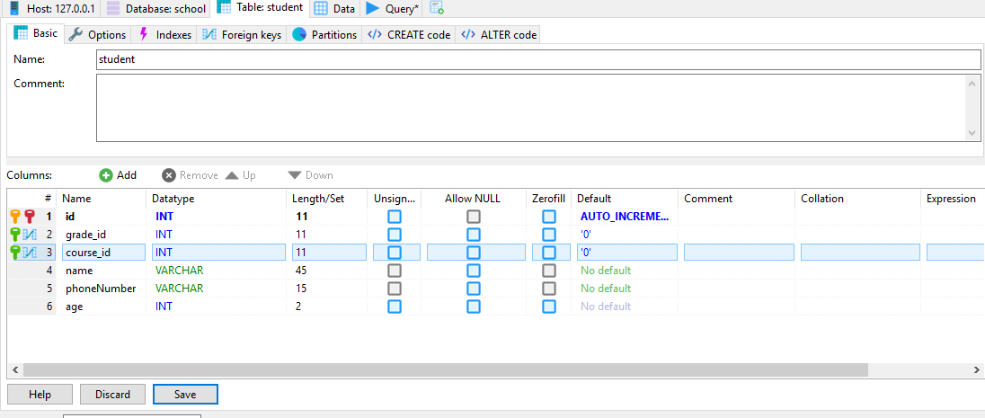

* I transferred the course entity to a table and for each attribute in the table it becomes a column

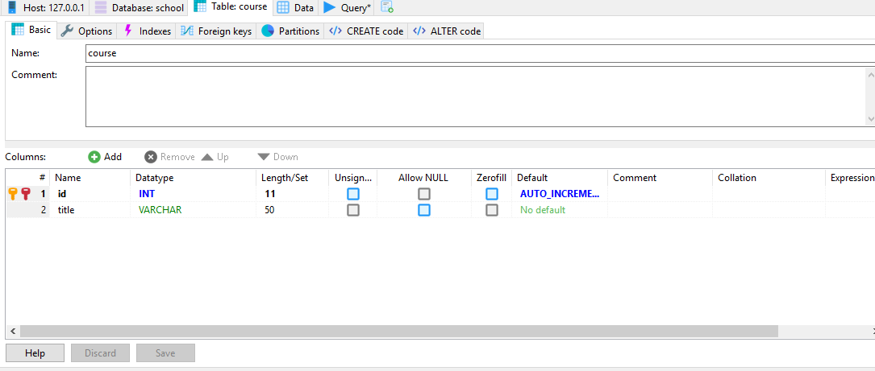

* Also, the same process applied to the grade entity which I translate it to a table.

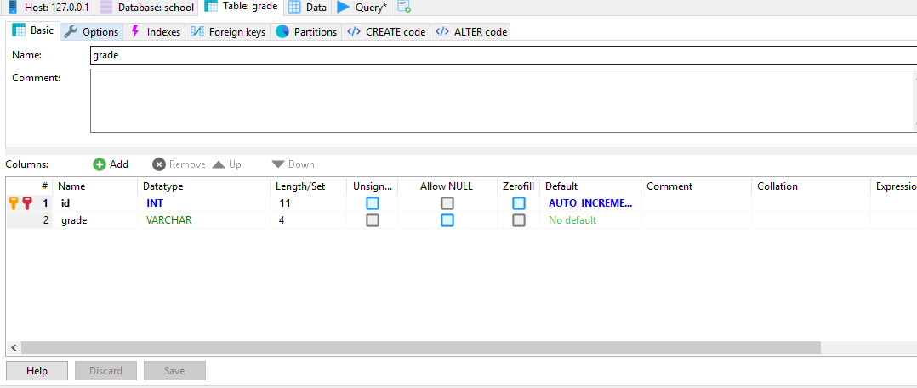

# Task 4:

I have used these queries regarding to the requirements:

1. SELECT * FROM student INNER JOIN course ON course.id = student.course_id INNER JOIN grade ON grade.id = student.grade_id
2. SELECT * FROM student INNER JOIN course ON course.id = student.course_id
3. SELECT * FROM student inner JOIN course ON student.course_id = course.id ORDER BY student.name
4. SELECT title,COUNT(course_id) AS NumberOfStudents FROM student inner JOIN course ON course.id = student.course_id GROUP BY title
5. CREATE VIEW Students_who_pass AS SELECT name, grade from student inner join grade ON grade.id = grade_id WHERE grade > 50